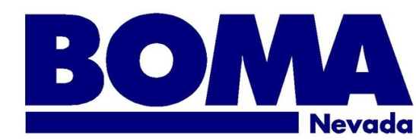
5TH ANNUAL GOLF TOU RNAMENT
Registration form

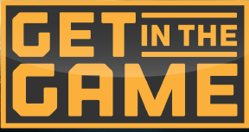

Spanish Trail Country Club 8:00 AM Registration
Thursday, October 25th 9:00 AM Shotgun Start

Seize the opportunity today to secure your BOMA Nevada Golf Tournament sponsorship.
Yes! My company would like to sponsor:

- Title Sponsor $5,000
- Gold $2,000
- Bloody Mary Bar $2,000
- Photography $1,500
- Raffle $1,500
- Lunch $1,000
- Golf Balls $1,000
- Towels $1,000
- Beverage Cart $1,000
- Putting Green $1,000
- Decoration $400
- Trophy $400
- Promotional Tee Sign/Hole $500

Sign me up to play Golf:

- Foursome $700
- Individual $175

Putt Putt (Individual):

- Member $45
- Non-member $50

Lunch only:

- Individual $40

Please provide team names:
Player 1: ____________________________ Player 3: ________________________________
Player 2: ____________________________ Player 4: ________________________________

Company Name: ____________________________________________________________________
(Note: this is the exact name that will be printed on the promotional material, signage, etc. included with the sponsorship)

Authorized Signature: ________________________________________________________________

Contact Person: _______________________________________ Phone: _______________________

Email: ______________________________________________________________________________

Invoice me at: Billing Address: _________________________________________________________________

_________________________________________________________________

OR Charge my credit card:

Name/ Company:__________________________________________________
Address:_________________________________________________________
City:_____________________ State:______________ Zip:_____________ Phone:______________
Credit Card: ______________________________________________________
Expiration:__________________ CSC:_____________
Authorized Signature: _______________________________________________
E-mail:___________________________________________________________

To reserve your sponsorship opportunity, please email or fax to: bomanevada@bomanevada.org | 702-798-8653.

All sponsorships are assigned based on first received. You will be invoiced for the sponsorship. Payment must be made prior at a minimum of 45 days before the tournament date.

For additional information, please contact either:
Mike DiFabbio: 702-254-0262, mdifabbio@nevgen.com or Tara Harvey: 702-938-2662, tara@amnevada.com

